

NAMIBIAN UNIVERSITY of SCIENCE AND TECHNOLOGY

GIS PROGRAMMING PROJECT REPORT
FIRE_ESCAPE: A Web-Based Wildfire Risk Visualization and Evacuation Analysis Tool

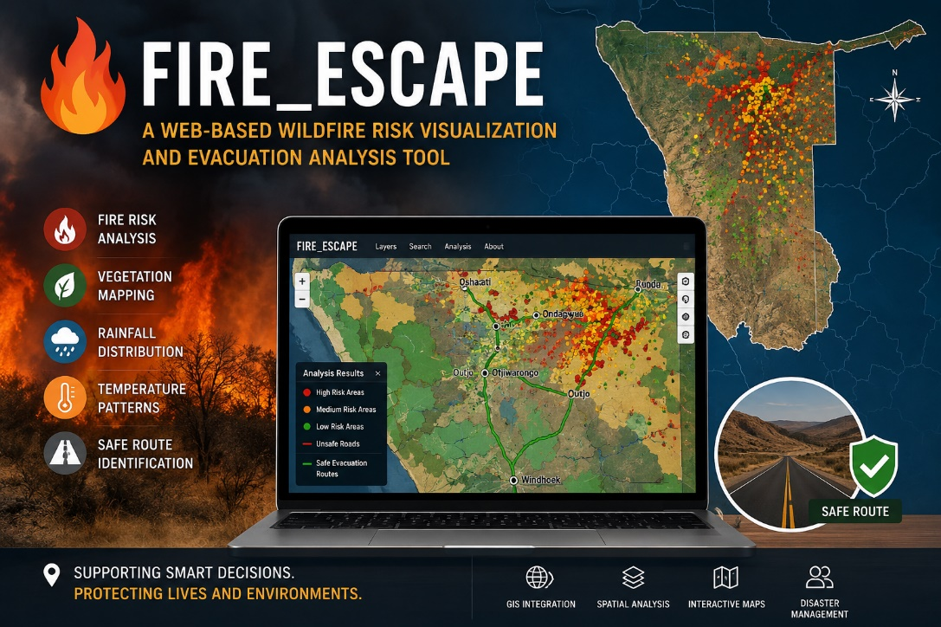

STUDENT NAME: HELVI KAINEKELWA IITA
STUDENT NUMBER: 223029904
COURSE: BACHELOR OF GEO-INFORMATION TECHNOLOGY
LECTURER: MR OLUIBUKUN AJAY
MODULE: GIS PROGRAMMING
CODE: GIP720S
DATE: 06 MAY 2026
FIRE_ESCAPE: A Web-Based Wildfire Risk Visualization and Evacuation Analysis Tool

Table of contents
1.Executive Abstract
2.Study / Project Background
3.Objectives and Justification
4.Methodology
- 4.1 Project Initiation
- 4.2 Import Necessary Libraries
- 4.3 Data Loading
- 4.4 Coordinate Reference System (CRS) Standardization
- 4.5 Layer Styling and Classification
- 4.6 Create Interactive Map (Folium)
- 4.7 Add Environmental Layers
- 4.8 Generate Heatmap Tool
- 4.9 Generate Analysis Tool
- 4.10 Location Tool
- 4.11 Generate ZIP Download Tool
5. Description of Results and Model Application
6. Conclusion
7.References
1.Executive Abstract
FIRE_ESCAPE is a Python-based interactive Web GIS application developed to support wildfire risk visualization and evacuation analysis in Namibia. The application integrates multiple geospatial datasets, including fire points, vegetation cover, rainfall, temperature, roads, towns, and regional boundaries into a dynamic web mapping environment. Using Python libraries such as GeoPandas, Folium, NumPy, Matplotlib, and Shapely, the system automates spatial data processing, visualization, and analysis. Key functionalities include wildfire risk classification, fire density heatmap generation, environmental layer visualization, safe road identification, geolocation services, and downloadable GIS outputs. The final product generates an interactive HTML map with embedded JavaScript functionality, providing a user-friendly platform for wildfire monitoring and emergency planning. The project demonstrates the effectiveness of Python automation and Web GIS technologies in improving environmental management and spatial decision-making.
2.Study/ Project background
The increasing frequency and intensity of wildfires in Namibia highlight the need for automated geospatial tools capable of supporting disaster preparedness, environmental monitoring, and evacuation planning. Namibia faces significant wildfire challenges, particularly in its savanna and protected areas like Etosha National Park, where fires are influenced by vegetation, low rainfall, high temperatures, and human activities. Wildfires affect biodiversity, livelihoods, tourism, and infrastructure, with burned areas expanding notably from southwest to northeast. Climate variability exacerbates these risks, making spatial tools essential for monitoring and response.
Traditional fire management relies on satellite data (e.g., MODIS via AFIS) and manual GIS processes, which can be time-consuming and less accessible. FIRE_ESCAPE automates data integration and visualization into a browser-based platform, bridging the gap between raw geospatial data and actionable insights. It targets users such as environmental agencies, park managers, emergency services, and the public, providing an open, interactive tool for exploring fire patterns alongside critical environmental layers.

3.Objectives and Justification
Objectives
- To develop an automated Web GIS application for wildfire risk analysis in Namibia.
- To classify wildfire incidents into different risk categories.
- To visualize environmental factors influencing wildfire occurrence.
- To identify safe evacuation roads using spatial analysis techniques.
- To create an interactive and user-friendly web mapping platform.
Justification:
- Wildfires pose risks to lives, infrastructure, and ecosystems
- Decision-makers require real-time spatial insights
- Automation reduces human error and improves efficiency
- Web GIS enhances accessibility for users without GIS software

4.Methodology
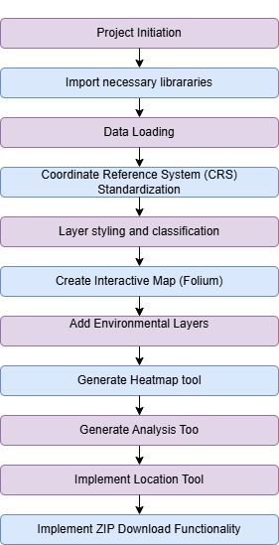

Materials and Methods
4.1 Project initiation
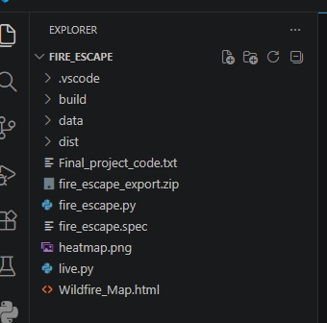
This stage involved defining the project idea: developing a Web GIS wildfire analysis and evacuation system for Namibia. The problem (wildfire risk and emergency response) was identified, and the overall system design was conceptualized. Including collecting all the data (shapefiles) to be used and the software as well as setting up my folder structure and connecting the folder to Visual studio.

4.2 Import necessary libraries
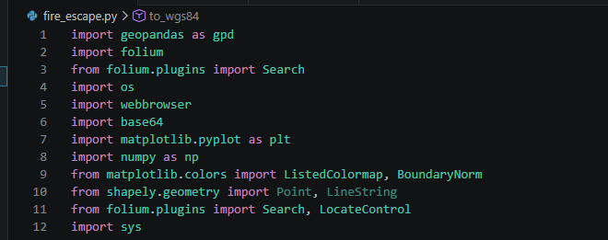
Importing libraries such as GeoPandas, Folium, Matplotlib, Shapely, and NumPy forms the technical backbone of the application. Each library serves a specific purpose — from handling geospatial data to creating interactive web maps. This step is crucial because it enables the automation of complex GIS tasks using Python. Without these libraries, the development of a robust, interactive, and compiled application would not be possible.

4.3 Data loading
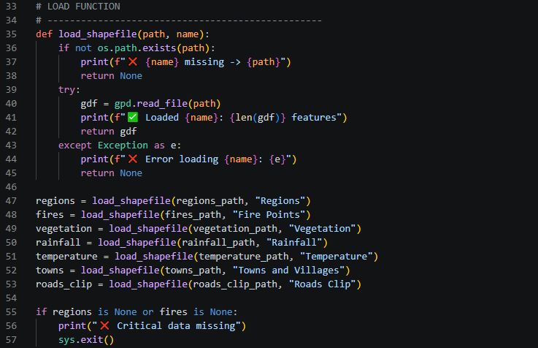
This step involves reading all shapefiles (fire points, regions, vegetation, rainfall, temperature, roads, and towns) using GeoPandas. It includes error handling to ensure missing or corrupted files do not crash the program. Proper data loading is essential as it brings real geospatial information into the system for analysis and visualization. This automation ensures the application is reliable and can work consistently across different user environments.

4.4 Coordinate Reference System (CRS) Standardization
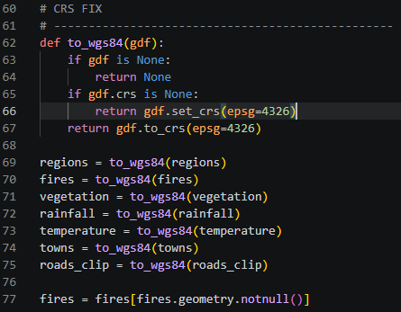
All loaded layers are converted to WGS84 (EPSG:4326) using a custom function. This standardization is critical because different shapefiles may have different projections, which can cause misalignment
on the web map. It ensures all layers overlay correctly and function properly with Folium/Leaflet. This step is vital for maintaining spatial accuracy and preventing display errors in the final interactive map.

4.5 Layer Styling and Classification
This step applies meaningful colors, symbols, and risk categories (High, Medium, Low) to and other layers using custom style functions. It makes the map visually intuitive and easy to interpret by users. Classification helps highlight high-risk areas and environmental patterns. This enhances the tool’s educational and decision-making value for stakeholders such as park managers and emergency services.

4.6 Create Interactive Map (Folium)
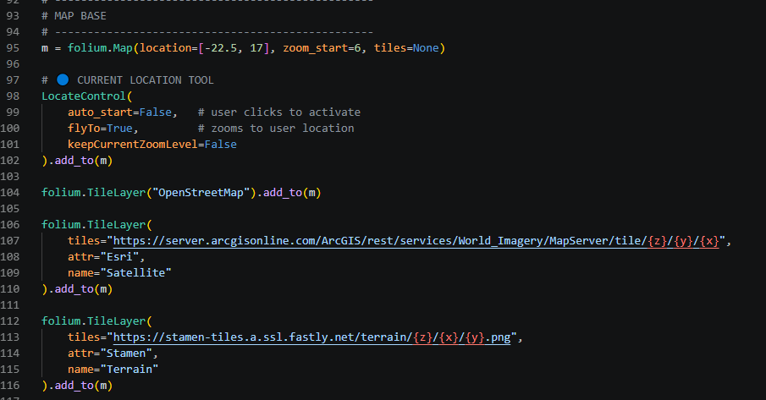
The base interactive map is created using the Folium library with multiple tile options (OpenStreetMap, Satellite, and Terrain). This establishes the platform where all geospatial data will be displayed. Folium converts Python code into a dynamic web map that runs in any browser. This step is important because it transforms raw data into an accessible and user-friendly interface.

4.7 Add Environmental Layers All processed layers (Regions, Fire Points, Vegetation, Rainfall, Temperature, Roads, and Towns) are added to the map with appropriate tooltips and popups. This integration allows users to explore relationships between fires and environmental factors. Layer control functionality gives users flexibility to toggle layers on and off. This step significantly increases the analytical and practical value of the application.

4.8 Generate Heatmap Tool
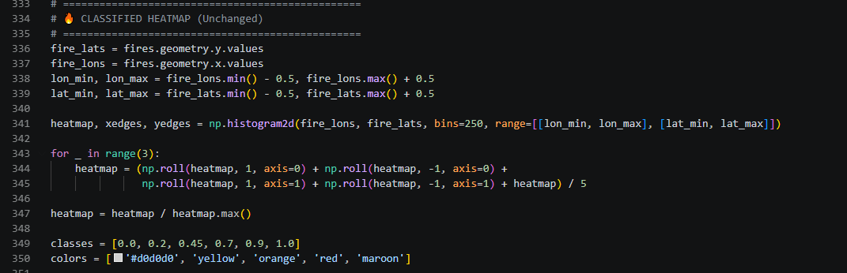
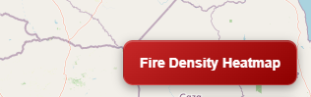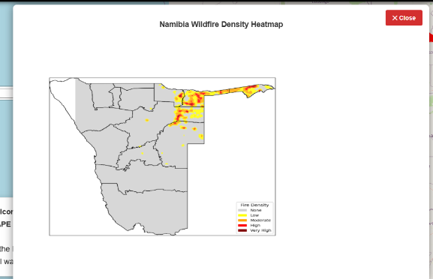
A fire density heatmap is generated using NumPy and Matplotlib, then embedded into the map as an interactive panel. This tool visually highlights wildfire concentration hotspots across Namibia. It provides a powerful overview that static layers cannot achieve. The heatmap is essential for identifying priority areas for prevention and rapid response.

4.9 Generate Analysis Tool
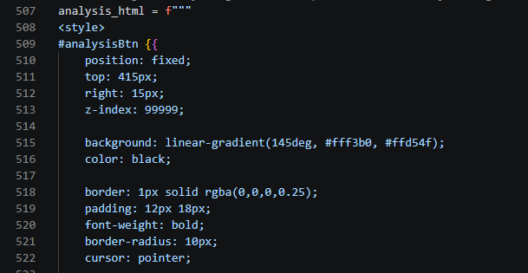
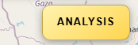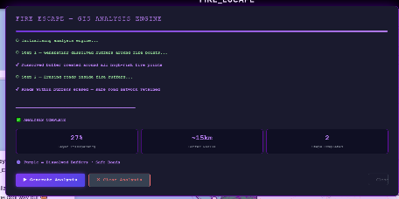
This step implements advanced spatial analysis including buffer creation around fire points and identification of safe roads outside the buffers. Buffer analysis was performed using Shapely’s geometric operations to identify high-risk fire zones and erase unsafe road segments intersecting the fire buffers The results are injected into JavaScript for live, on-demand visualization with progress logging. It automates complex GIS operations that would otherwise require manual processing. This feature makes the tool highly valuable for evacuation planning and risk mitigation.
4.10 implement Location Tool
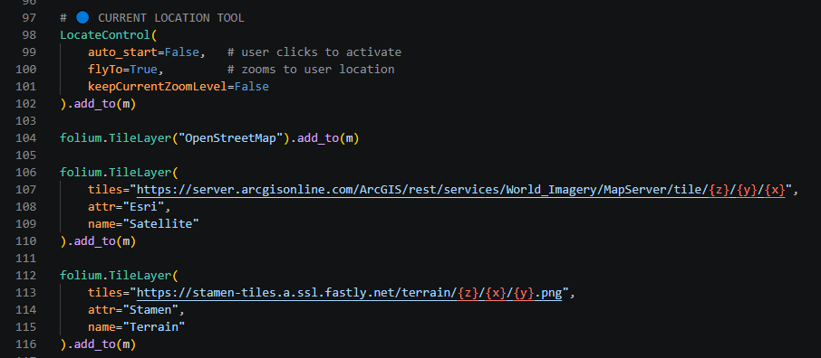
The LocateControl plugin is added to allow users to find their current geographical position on the map. This enhances real-world usability, especially for field officers or people in fire-prone areas. It supports quick decision-making by showing proximity to fire risks and safe routes. This tool bridges the gap between digital visualization and on-ground application.

4.11 Implement ZIP Download Functionality
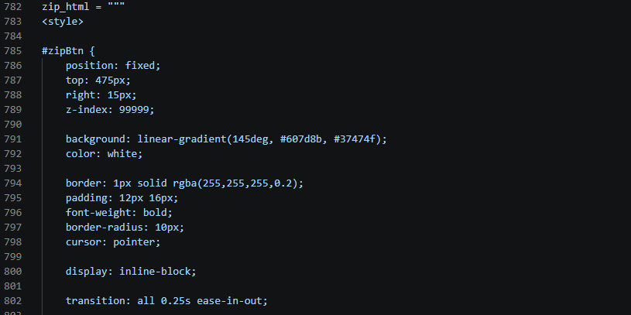
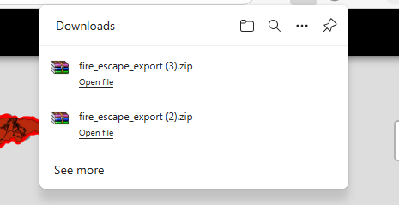
A ZIP export feature is created containing the HTML map, heatmap image, and all shapefiles. This ensures users can easily share or archive the complete project deliverables. It improves portability and fulfills submission requirements. This final step demonstrates professionalism and makes the tool practical for both academic and real-world use.

Final output browser
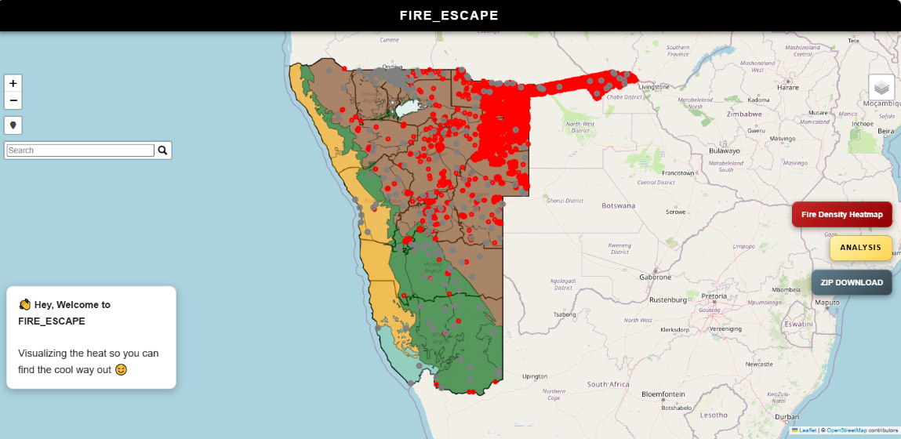
5.Description of Results/Model Application
The application produces an interactive Wildfire_Map.html featuring a national overview centered on Namibia. Users toggle layers (Regions, Fires, Vegetation, Rainfall, Temperature, Roads, Towns) via Layer Control. environmental layers use intuitive colour schemes with tooltips.
The Fire Density Heatmap button opens a detailed Matplotlib-generated image showing smoothed hotspots clipped to regions. The ANALYSIS button triggers a live engine: purple buffers around fires (~15km), safe road overlays (erasing high-risk segments), progress tracking, and summary statistics.
The Location Tool in the FIRE_ESCAPE application is implemented using Folium’s LocateControl plugin. This tool adds a button on the map that, when clicked, detects the user’s current geographical position using the browser’s GPS or network-based location services. Once activated, it automatically centers the map on the user’s location with a marker and zooms in for better visibility
In wildfire emergency situations, knowing one’s exact current location relative to active fire points, high-risk zones, and safe roads is critical for survival. The Location Tool allows users — such as park rangers, tourists, local communities, or emergency responders — to instantly see how close they are to nearby fire incidents, fire buffers, and dangerous areas.
Additional features include geolocation, enhanced search, ZIP download, and responsive UI. The tool demonstrates high performance, with all layers loading efficiently and analyses completing in seconds. It visualizes correlations and supports practical use cases like identifying safe evacuation routes.

6.Concluding Remarks
FIRE_ESCAPE successfully delivers an automated, interactive GIS solution for wildfire management in Namibia, integrating data processing, visualization, and analysis into a single executable web app. The project successfully meets the GIS Programming course requirements by demonstrating substantial Python automation, spatial analysis, interactive visualization, and Web GIS implementation. Future enhancements could include real-time data feeds, advanced predictive modelling (e.g., MCDA), or mobile optimization. This project underscores the power of open-source geospatial programming in addressing environmental challenges.

6.References
Bellingcat. (2025). Wildfires Ravage One of Africa’s Largest Nature Reserves. 7 October 2025. Available at: https://www.bellingcat.com/news/2025/10/07/wildfires-ravage-one-of-africas-largest-nature-reserves/

Advanced Fire Information System (AFIS). (2025). AFIS Map Viewer. Available at: https://www.afis.co.za/

